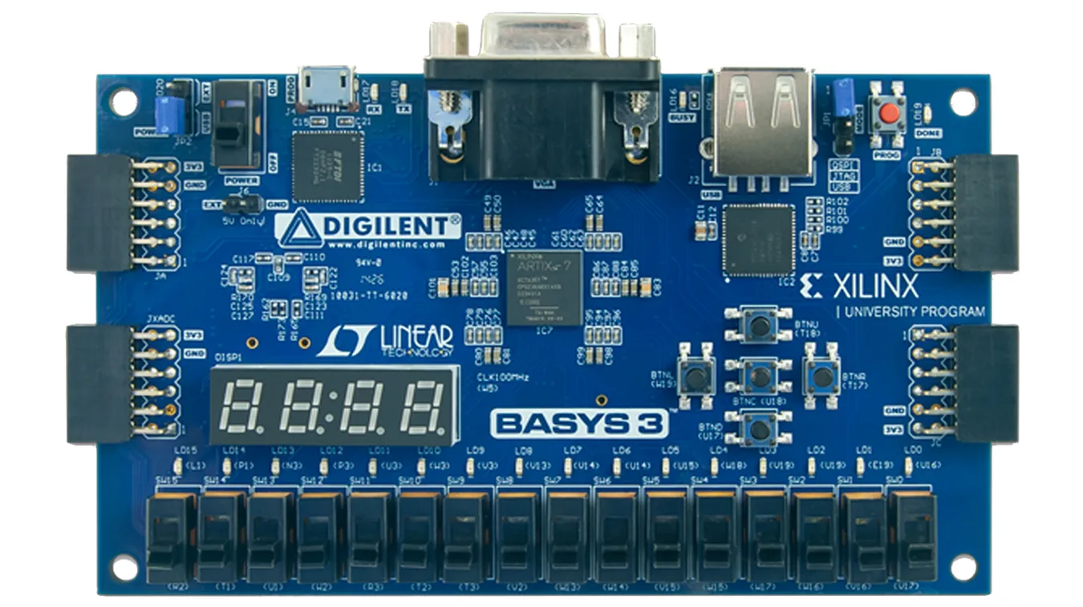
[0:2] fanspeed
[5:0] door_pinLED
[2:0] alarm_pinLED
idle_reset
change
room temperature
garage door state
collision
[0:3] desiredSW
ONOFF
[0:3] outsideSW
pin0
pin1
garage_controller

